***Assignment 2***

Using Sandbox from the AWS Educate Website I Have designed a three-tier web application which is to be hosted on AWS cloud, while adhering and incorporating all the good practices and methods thought in the module over this semester. This Application has a multi-AZ web server and database design. My design adheres to the five pillars of a well-architected architecture which has makes the application very reliable for the designs that has been made.

Below is an image of the architecture of my application follows:

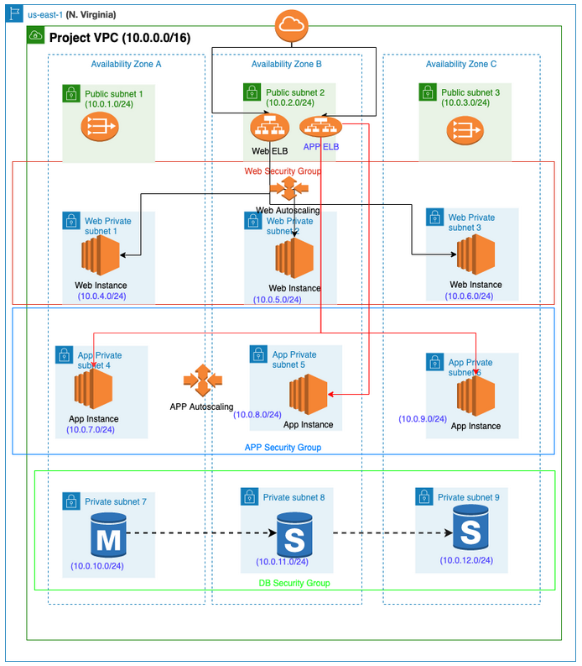

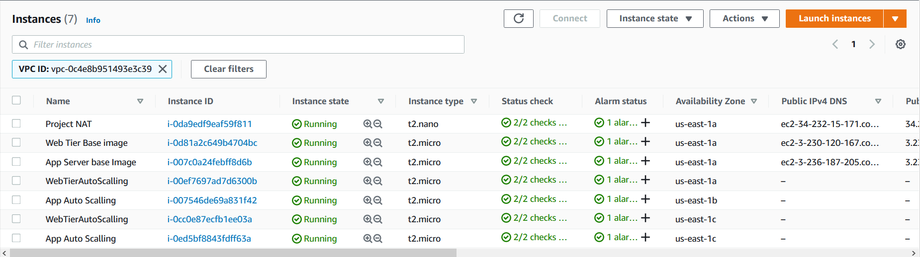

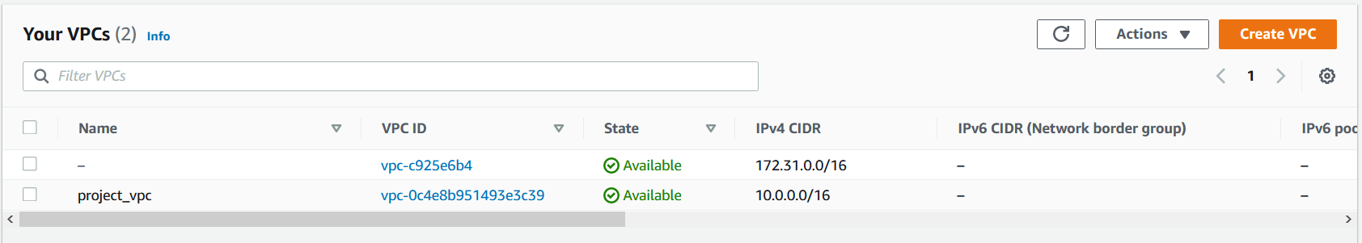

***Screenshots of work:***

***Subnets:***

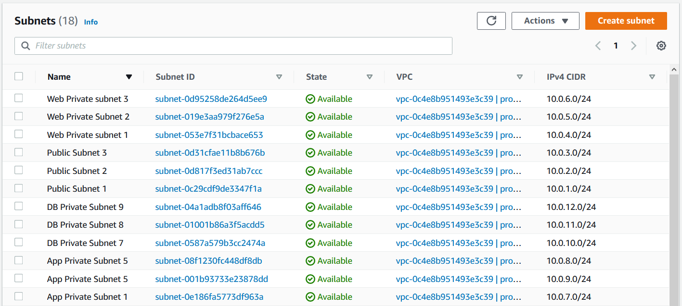

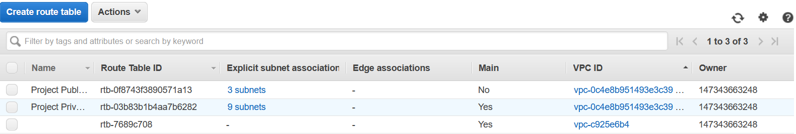

***Load Balancers:***

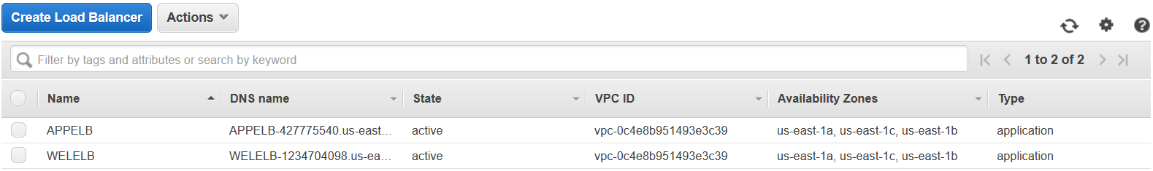

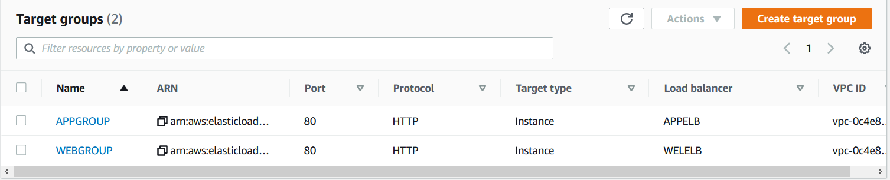

***Autoscaling groups:***

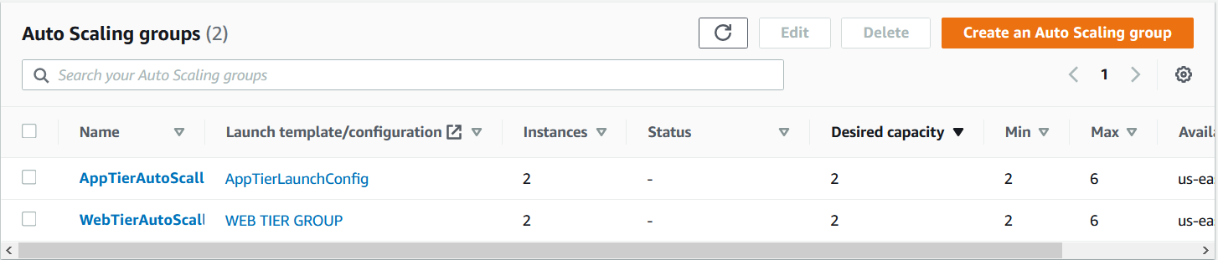

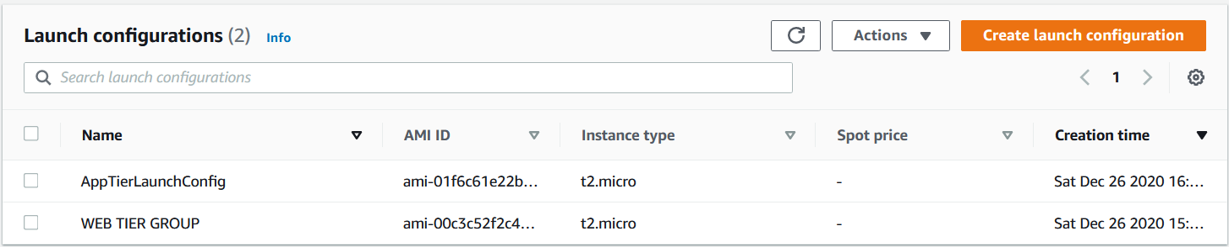

***Web ELB:***

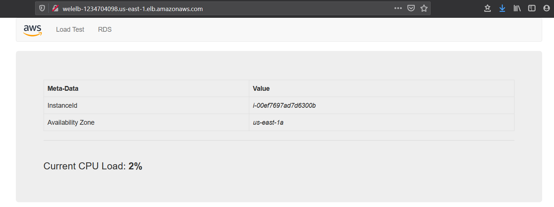

***App ELB:***

